How to Make Cheese Pizza
- First, roll out the pizza dough.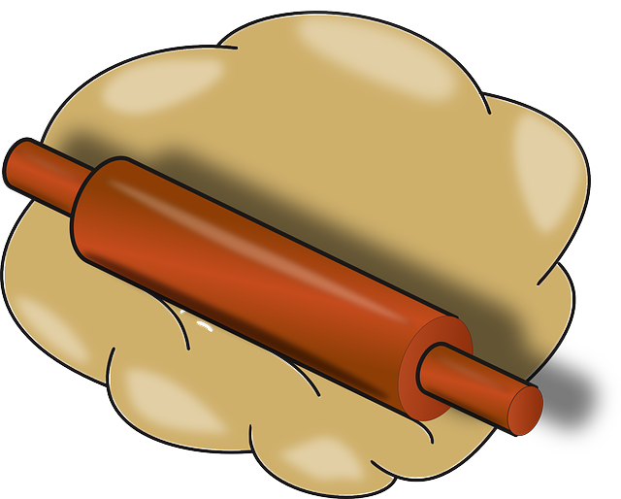
2.Next, spread the tomato sauce.
3.Then, sprinkle the cheese on the sauce.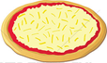
4. After that, put the pizza in the oven.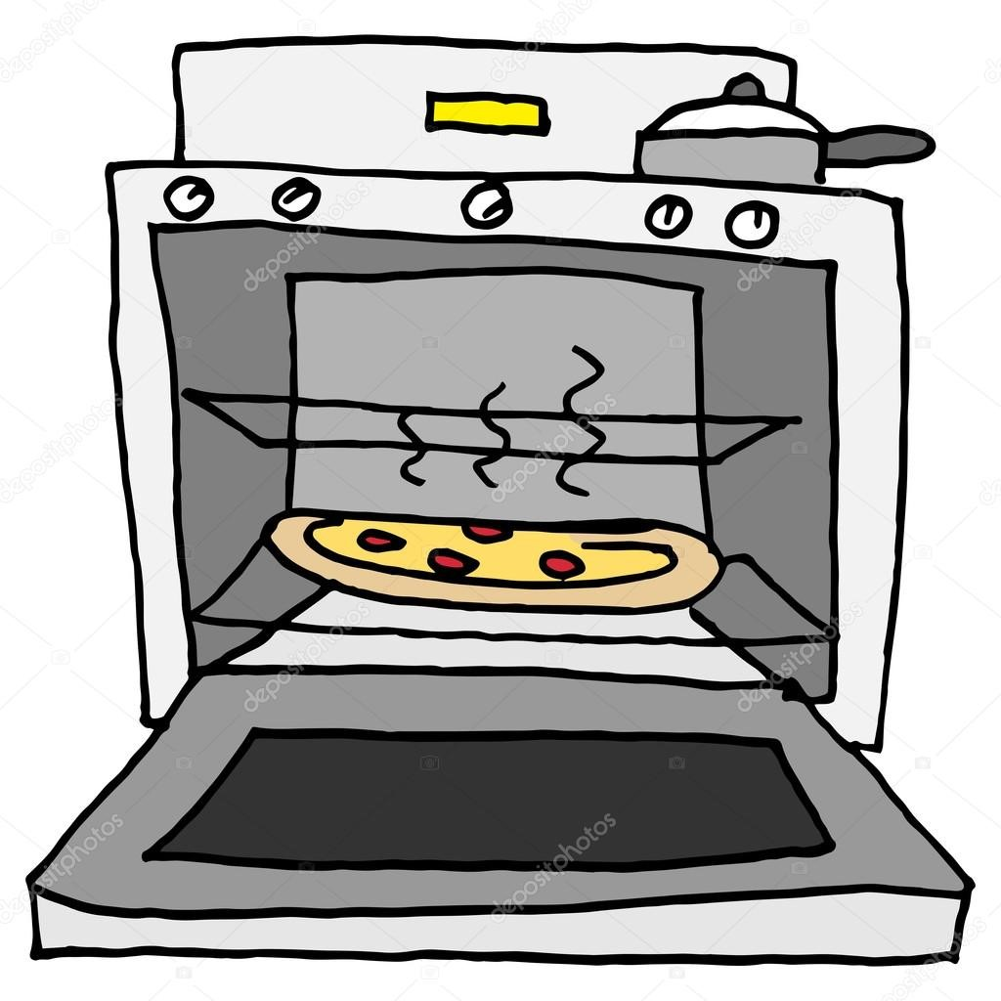

5. Finally, cut your pizza into slices.

